Date: December 14, 1999
To: DACT
Cc: CJB
From: Dhanada Mishra
Re: Market Potential for AKWA Sheet Technology in India

Having recently returned from a personal trip to India, here is my assessment of the potential for the AKWA sheet technology for India in the long term and in the Cyclone affected coastal regions in the short term. A brief summary of damages caused by the cyclone is attached. The sheer magnitude of the damage is immense and it will take several years of sustained effort to bring back the region to its pre-cyclone status.

The AKWA tank is a uniquely suitable product for the developing countries such as India. The labour intensive fabrication process (needing almost artisan type of skills) can be quite suitable for Indian manufacturing conditions characterised by low labour costs. One can visualise a low cost housing unit easily fabricated out of the AKWA sheets rolled to larger diameters, mud plastered interiors and thatched roof for insulation and suitable openings in the wall for doors and windows. The shape of the basic structure resembles mud houses traditionally used by many communities. Given the potentially large size of the market (1.7 - 2.4 million housing units, 14000 schools damaged in the cyclone affected area alone), in a region marked by high population density and short distances between population centers will favour the cost economics of manufacturing, transporting and selling the product.

What will make the product viable is collaboration between aid agency, local entrepreneur in building industry and the state government with the funds to subsidise the housing/tank units or provide soft loans for the same. Potential collaborators could be Habitat International, UNDP, Community Aid Abroad amongst the international aid agencies working in the area and several local NGOs and private entrepreneurs and companies that I have worked with or known personally. Australian government can be a partner through its AusAID program. I think this idea should be particularly attractive for the Government funding agencies given that it opens up the South Asian market to a new Australian technology with future potential for commercial operations. On the other hand, there is significant money available from State and Federal Government in India for the housing sector, which can potentially be tapped through the local partners.

It appears that this is an unique opportunity for Rocla to not only earn a lot of good publicity by providing an appropriate technology to a particularly needy region of the world, but also open of future business opportunities.

DKM

Summary of damage from Super-Cyclone (29th October 1999)

Sl. | Category | Magnitude
1. | Wind Speeds | 160 mile/hr or 300 km/hr; Category 5
2. | Tidal wave | 20-30 feet of water into 25 kms inland
3. | No. of people affected | 12.5 million
4. | No. of people dead | 10,000 (official)  50,000 - 200,000 (unofficial)
5. | No. of Cattle dead | 350,000
6. | No. of trees uprooted | 90 million
7. | Crop loss | 60 - 90%
8. | No. of villages affected | 14000
9. | No. of houses damaged | 1.65 million
10. | No. of houses completely destroyed | 23,000
11. | No. of school buildings damaged | 14000
12. | Length of roads damaged | 7500 kms
13. | Estimated Damage | $ 4 to 5 billion
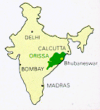
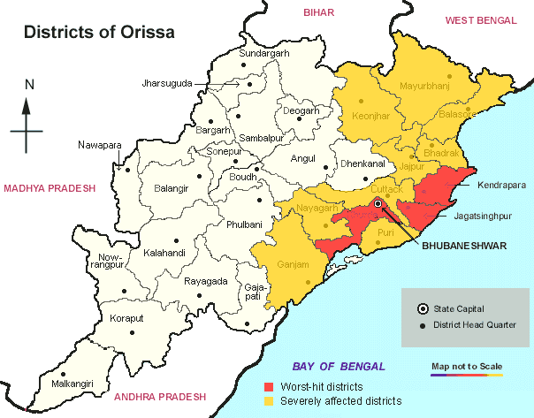
Where is Orissa?

